Research Document

This document prepared to determine which technologies to use in the project.
This project going to provide users with golf handicap tracker.

Introduction

This research document is the basis for the third-year project. It will study technologies which are going to be considered for this project.
In this research, there will be a comparison of already existing systems on the market. And highlighting the aspects which are going to be better or different in the new project.
After the thorough consideration, team members going to choose most suitable software and technologies.

Comparison with similar systems

Hole19
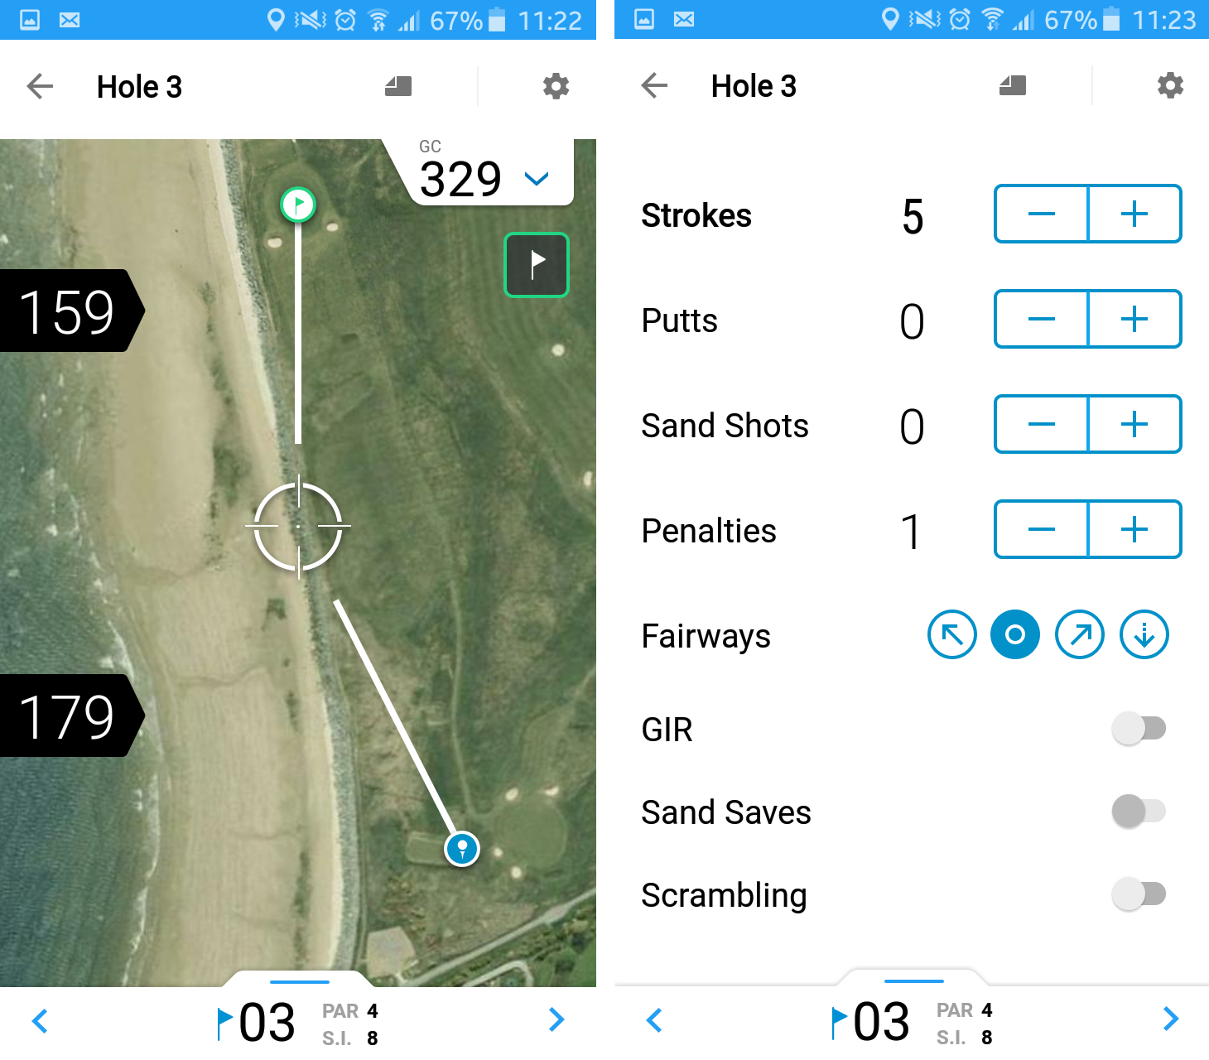

Hole19 is an app created for android and iOS systems, it features the ability to track your scores throughout a “round”, and displays your statistics after the round is completed. This app is notable for having a very user-friendly design, being very simple to use and having very clear displays for your round statistics. Due to the nature of this being an application designed for phones, it is limited in the statistics it can track, and as such only covers the essential areas of the user's game, and even then, not in the most detail. Since this project will be accessed mostly using a computer, it can cover these areas in more detail, and as such give a complete overview of the user's game.

Keepmygolfscore.com
Like this project, keepmygolfscore is a web-based system that tracks the user's statistics and handicap after rounds. While this allows it to be detailed about the user's statistics, it is not presented in a very clear manner. The handicap system it has is also unfriendly to use, as it requires 12 rounds to be input before the user receives a handicap. While this has the benefit of giving a user a more accurate initial representation of their skill level (i.e. The system used by the project could give an initial handicap several shots above or below), it also means the user must wait a long time before they can get a handicap (assuming the user only plays 1 full round a week, this would mean they should use the system for 3 months before they get their handicap).

Technical aspects of the project
Intended users going to use this online web application over a web browser. The performance of this web application is not going to depend on platform or language in which it will be written. Thus, our team going to choose framework and language which is more comfortable for us, and give less trouble. Below is considered some possibilities for our project.

3.1 Languages
C++
C ++ is widely used for software development, being one of the most common, the most commonly used programming languages. The area of application includes the creation of operating systems, a variety of applications, device drivers, applications for embedded systems, high-performance servers, and entertainment applications (games).
The biggest advantage of C++ language, that it is faster than other languages, it has direct access to hardware without a virtual machine in the middle. Due to the nature of the application not having any major performance requirements this advantage of C++ is not necessary.
Difficulties:
A memory leak is an uncontrollable process of reducing the amount of free RAM. This could be a big challenge when using C++. Therefore, it will need some additional code to control memory.

Java
Disadvantages:
Per shootout.alioth.debian.org site for seven different tasks, the Java averages runtime two times slower than C++.
Benefits:
Java applications are usually compiled in a special bytecode, so they can run on any computer architecture, using Java Virtual Machine. Another important feature of Java technology is a flexible security system, in which the execution of the program is fully controlled by the virtual machine. Additionally, Java has a special process called garbage collection which periodically frees the memory by removing objects that are no longer in demand applications. Thus, comparing with C++, Java is preferable for our project.

3.2 Frameworks

AngularJS
AngularJS - JavaScript framework with open source. Designed for single-page application development. The goal of AngularJS is an expansion of browser-based applications based on MVC-pattern, as well as simplification of testing and development.

Play Framework
Play - the development of open source framework written in the Java and Scala, uses a design pattern Model-View-Controller (MVC). It aims to increase productivity by using the coding by convention, display the error in the browser and the hot reloading of the code. Play 2 is stateless and is fully RESTful.

3.3 Databases
MySQL
MySQL open-source relational database management system. Development and support by Oracle Corporation, which received the rights to the trademark, together with the absorbed Sun Microsystems. It is a solution for small to medium-sized applications.
H2
H2 cross-platform open relational database management system written entirely in Java. Despite its small size (just over 1 MB), H2 supports many features. Including built in client-server, data encryption, browser management console.

Conclusion
Considering all the choices of frameworks, languages and databases, and since we have a lot of experience with some technologies in the second-year project, we concluded that the best choice for our third-year project will be Java language, Play framework and H2 database management system.

